**Graphics Mid-Sem Examination**

*Submitted to*

Mr. Durgansh Sharma

Professor, Cybernetics SCS, UPES

Submitted by

Name-PRANAY MAHAJAN

Roll no-R100218037

Sap ID-500068668

B. Tech CSE (OSSOS)

Department of Cybernetics

COMPUTER SCIENCE & ENGINEERING



**School of Computer Science**

**University of Petroleum and Energy Studies,**

**Dehradun – 248007: Uttarakhand**

**Table of Contents**

**ABSTRACT** 3

**Mid Term Phase 1: GIMP** 4

Topic: Creation of Naruto Shippuden Poster 4

• Procedure:- 4

Typography:- 6

**Mid Term Phase 2: BLENDER**

Topic: Naruto Shippuden Fight Scene

# **ABSTRACT**

* The aim of phase-1 is to create a Naruto Shippuden poster on GIMP and the aim of phase-2 is to create a Naruto Shippuden fight scene on Blender.
* For Phase-1, there are a total of five layers including the Background layer.
* Two of the layers are for the text, one for the character, one is the background itself and a transparent layer.
* Different kinds of GIMP tools are used for the creation like the paths tool, bucket fill tool, smudge tool, paintbrush tool, text tool, etc.

# **Mid Term Phase 1: GIMP**

## **Topic: Creation of Naruto Shippuden Poster**

## Procedure:-

1. Create a new image of size 1080x1080 pixels with background colour as white.

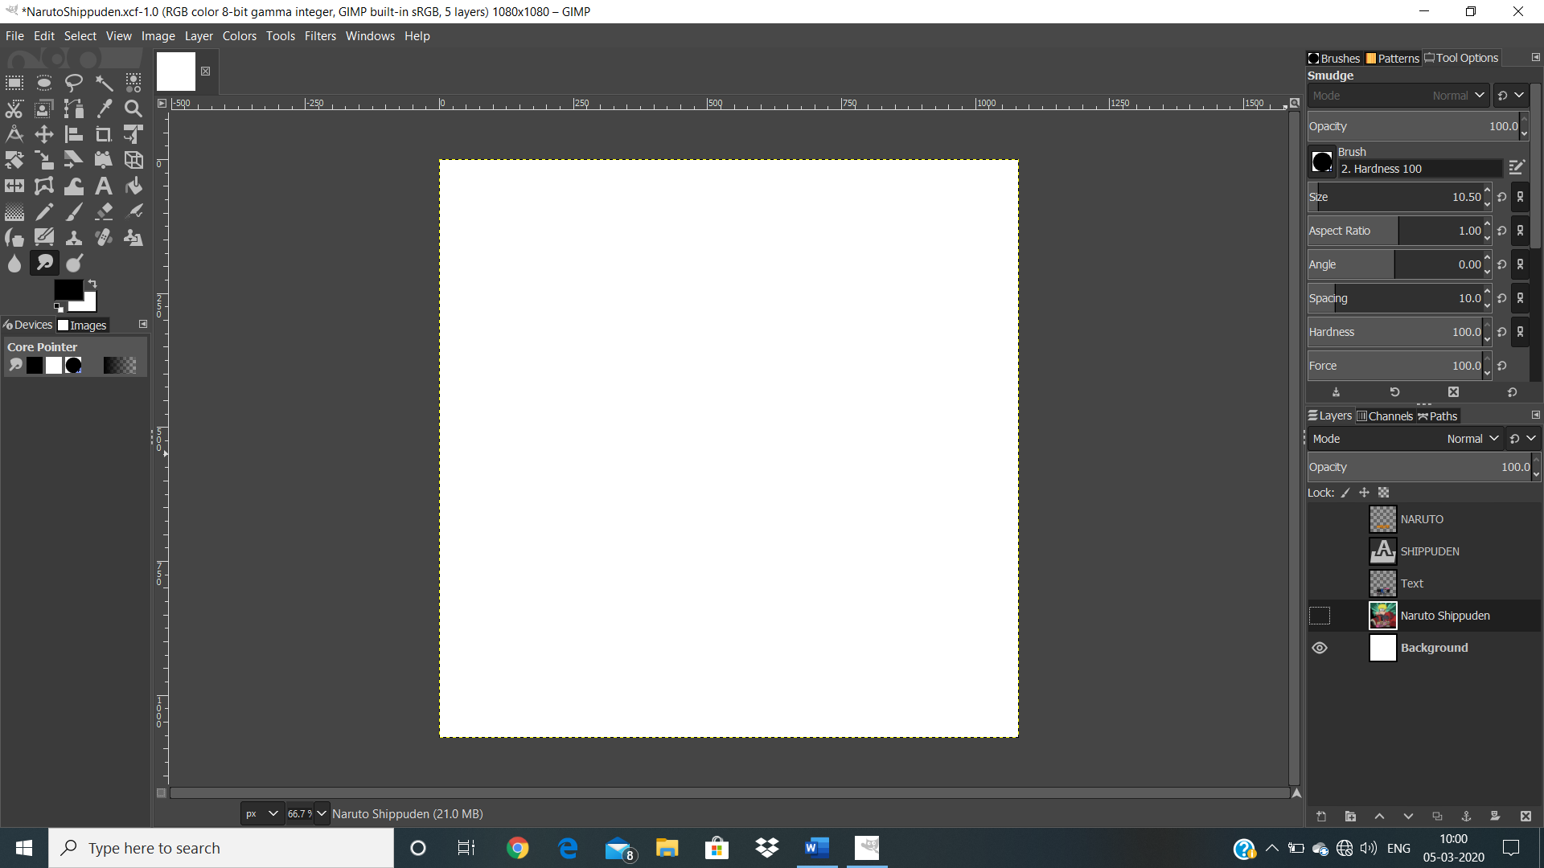

1. Open the desired image as a new layer and create a transparent layer over it.
2. With the help of the paths tool, draw the character and stroke it with the stroke

line colour as solid and assigning a particular line style.

1. Sketch the Background and add then with the help of the bucket fill tool, fill different areas of the character with desired colours.

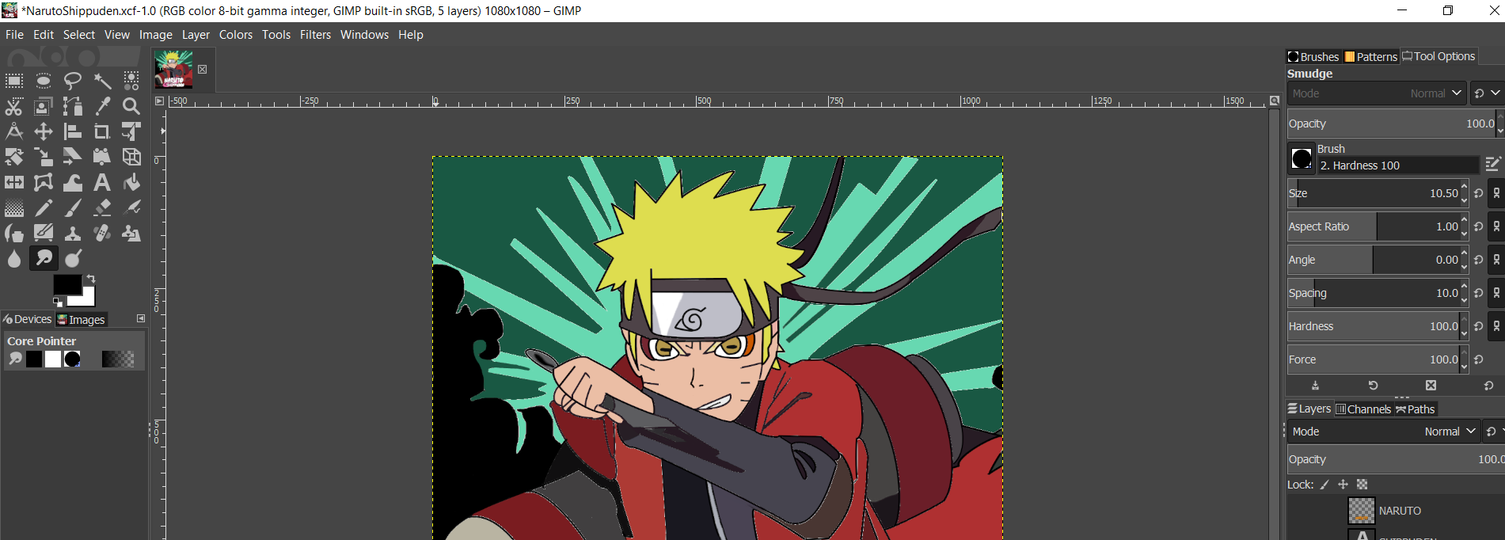

1. Use the Smudge tool, to mix different colours wherever required.
2. Now, add the text “Naruto Shippuden” to it with the help of the Text Tool. Assign a particular size and by using the font “Ninja Naruto” write the text. For the text, I have used Tight Tracking.

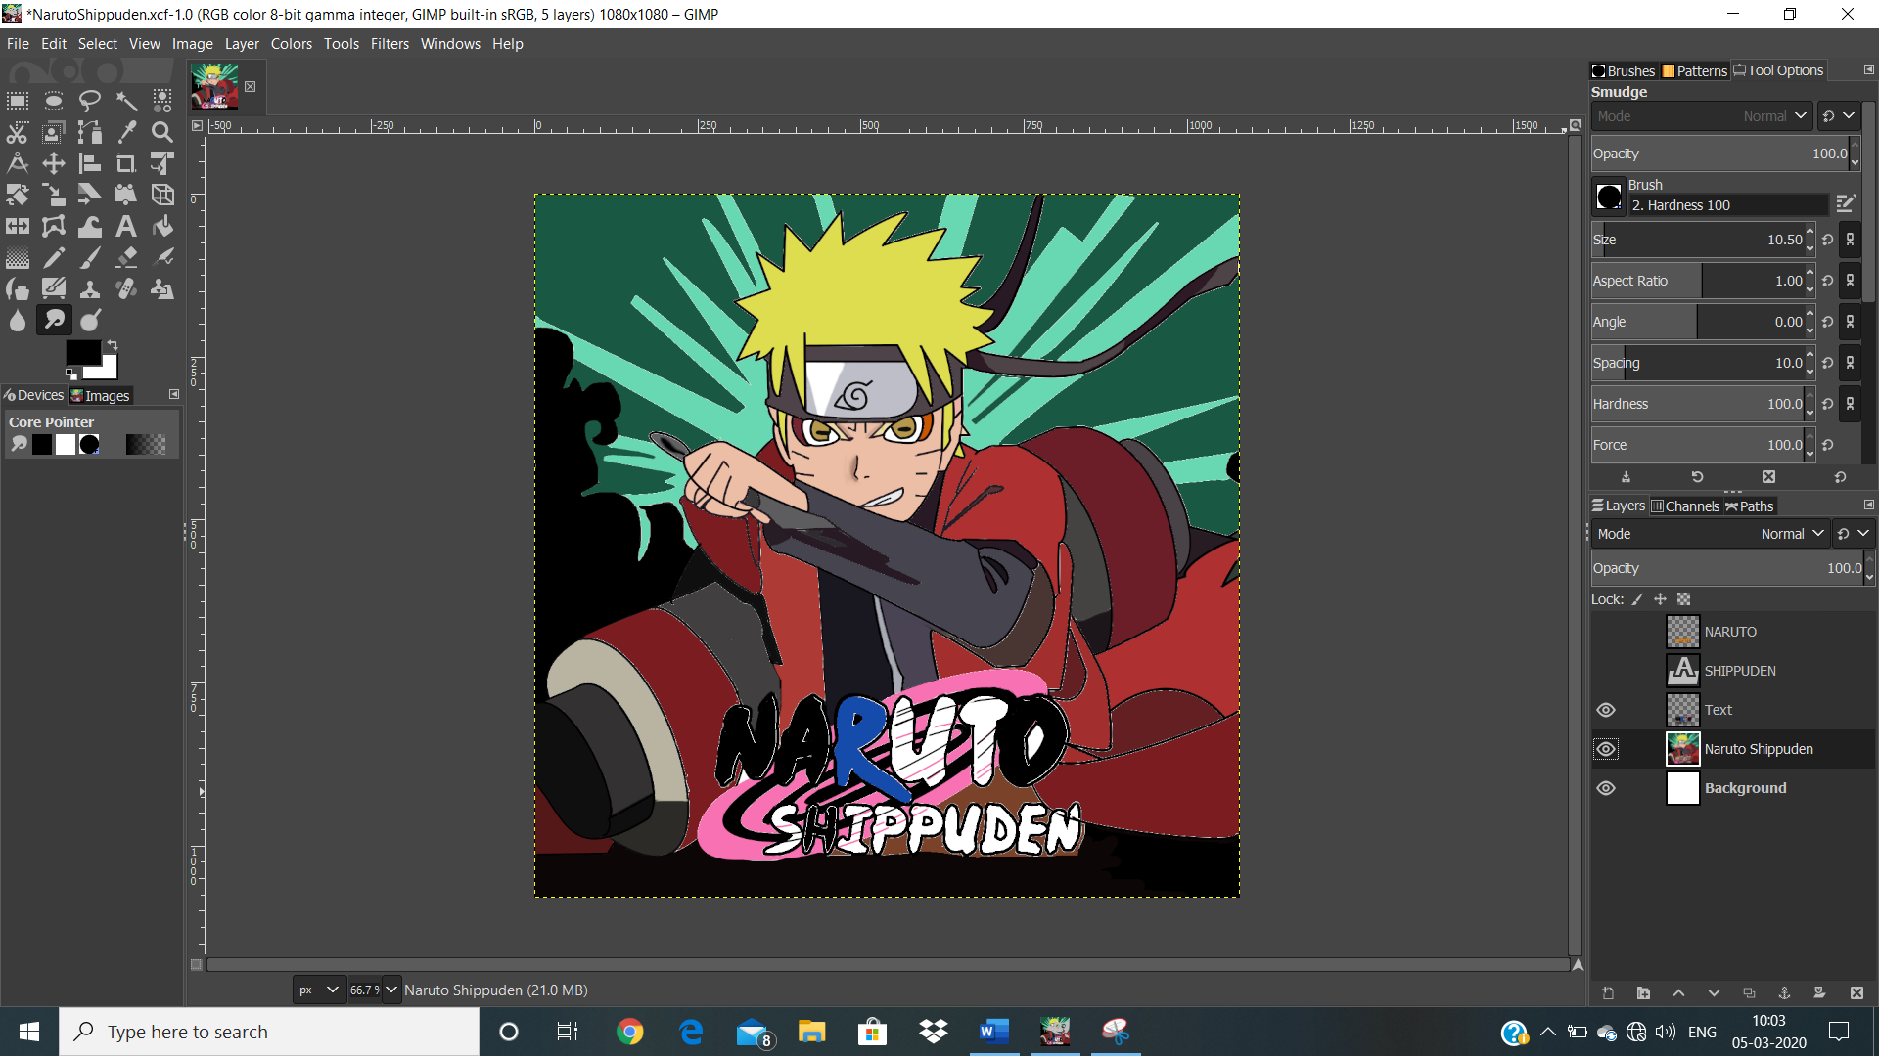

1. Give the Text a certain colour with the Bucket Fill Tool and saturation by selecting Hue-Saturation tool from the colours layout.

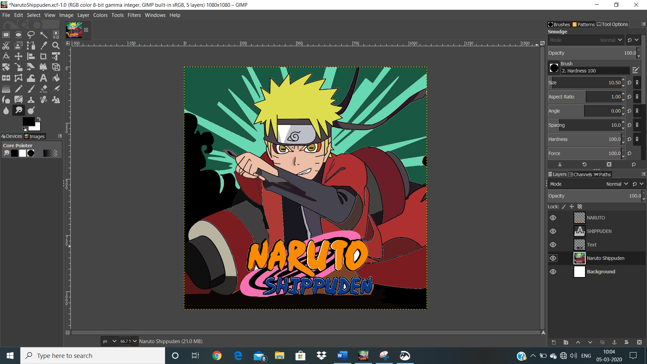

1. When Done, Save the file with the extension .xcf and assign a particular name to it.

### Typography:-

1. Font Used - Ninja Naruto
2. Size – 100 px for the Text “Naruto” and 80 px for the Text “Shippuden”.
3. Kerning - 3.0 pt.
4. Leading – 1.0 pt.
5. Tracking – The tracking used for the text is “Tight Tracking”. This is because the original Naruto Shippuden logo has a very minute spacing between each other.

